Software Installation
This section outlines the step-by-step installation procedure for the support packages and drivers required for Simulink compatibility. Follow the procedures in the order presented.

WARNING: FAILURE TO FOLLOW THESE INSTRUCTIONS IN THE ORDER PRESENTED COULD CAUSE MALFUNCTIONS!

1.1 Initial Setup
To ensure stability, have a fresh installation of MATLAB 2023b, or MATLAB 2024a with the following add-ons.
- Simulink
- Embedded Coder
- MATLAB Coder
- Simulink Coder
- C2000 Microcontroller Blockset
- Motor Control Blockset
- Fixed-Point Designer
+++++

1.2 Embedded Coder Support
- Open MATLAB/Simulink
- Navigate to the “Home” tab
- Open the Add-On drop down menu
- Select “Get Add-Ons” (See Figure 4)

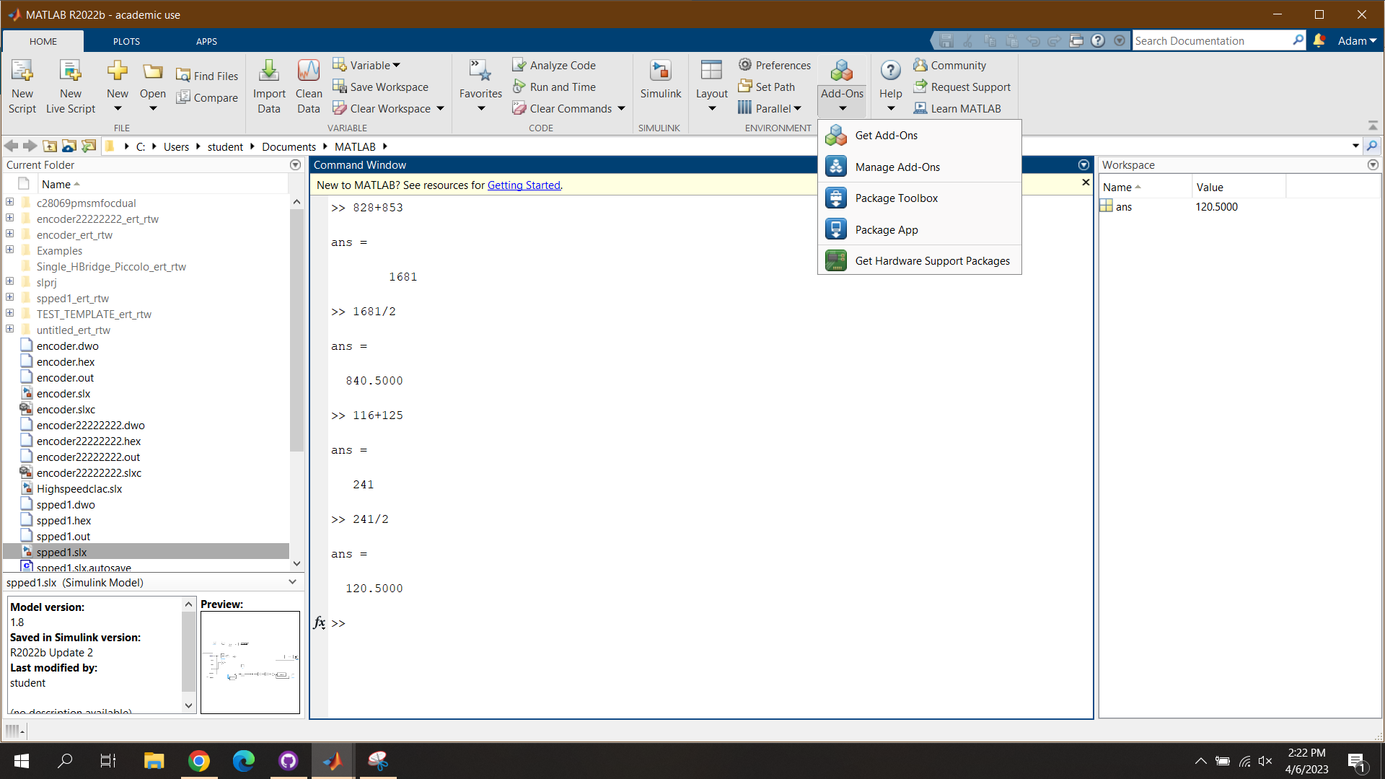

Figure 1: MATLAB Add-Ons Tab

- Using the search bar in the top-right corner, type the following.
  - “C2000 Microcontroller Blockset”
- On the right side of webpage click the install button (Figure 5)
  - This should download the support package to Simulink
  - A pop-up window will appear with instructions for installation.
  - Proceed to the next section; DO NOT close the pop-up window.

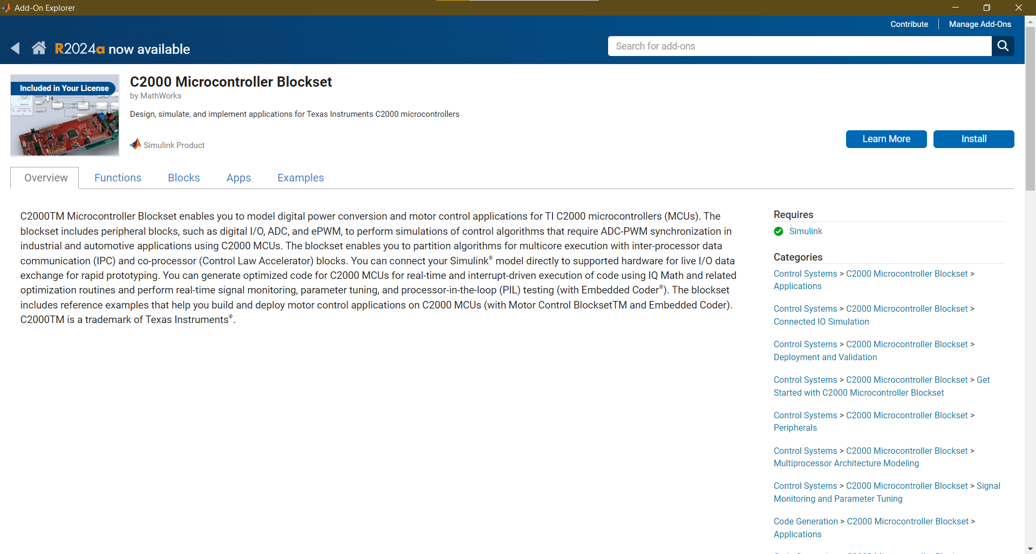

Figure 2: C2000 Microcontroller Blockset Download Page

The other add-ons can be installed similarly to this process. IF USING MATLAB 2024a OR LATER, THE FOLLOWING STEPS DO NOT NEED TO BE COMPLETED. The new C2000 Microcontroller Blockset removes the need for third-party code generation tools.

1.3 Code Generation
After installing the support package seen above, third-party code generation tools must also be installed. IF USING MATLAB 2024a OR LATER, THE FOLLOWING STEPS DO NOT NEED TO BE COMPLETED. The new C2000 Microcontroller Blockset initialized hardware automatically.
- If the installation pop-up window from the Embedded Coder Support Package is still open, skip to Step 7, otherwise continue in the order provided.
- Like the previous section, navigate to the MATLAB Add-ons tab
- Select the “Manage Add-ons” options
- Get add ons
- Find the Add-on tab for the C2000 Embedded Coder Support Package
- On the far right, select the button that looks like a machine gear
  - A pop-up window will open, beginning hardware setup
- Skip Step 8
- If the installation pop-up window still open, select the option labeled “Setup Now”
- With the Hardware Setup Wizard open, select the proper C2000 LaunchPad
  - Find the option labeled “TI-Piccolo F2806x”
  - Select this option like in Figure 6
  - Click Next

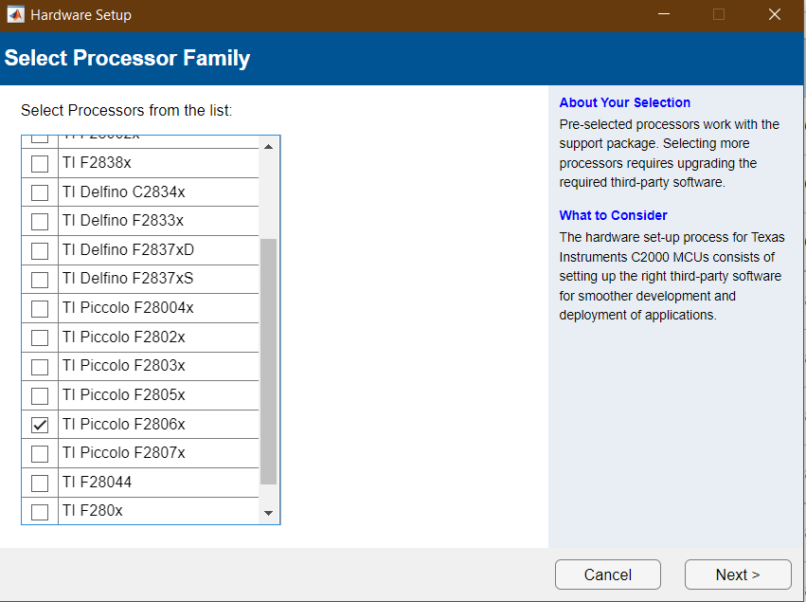

Figure 3: Processor Selection Screen

- Following the directions on-screen, install the Third-Party Tools highlighted in Figure 7
  - At the top of the window, select the option labeled “Automatically download and install”
  - In the bottom right corner, select the blue button labeled “Install”
  - Installation packages may vary depending on MATLAB Add-ons present on installation, as well as TI-LaunchPad versions selected on the previous page.
    - TI C2000 Code Generation Tools ver20.2.1 is mandatory
  - Successful installation will look like Figure 8
- Click Next

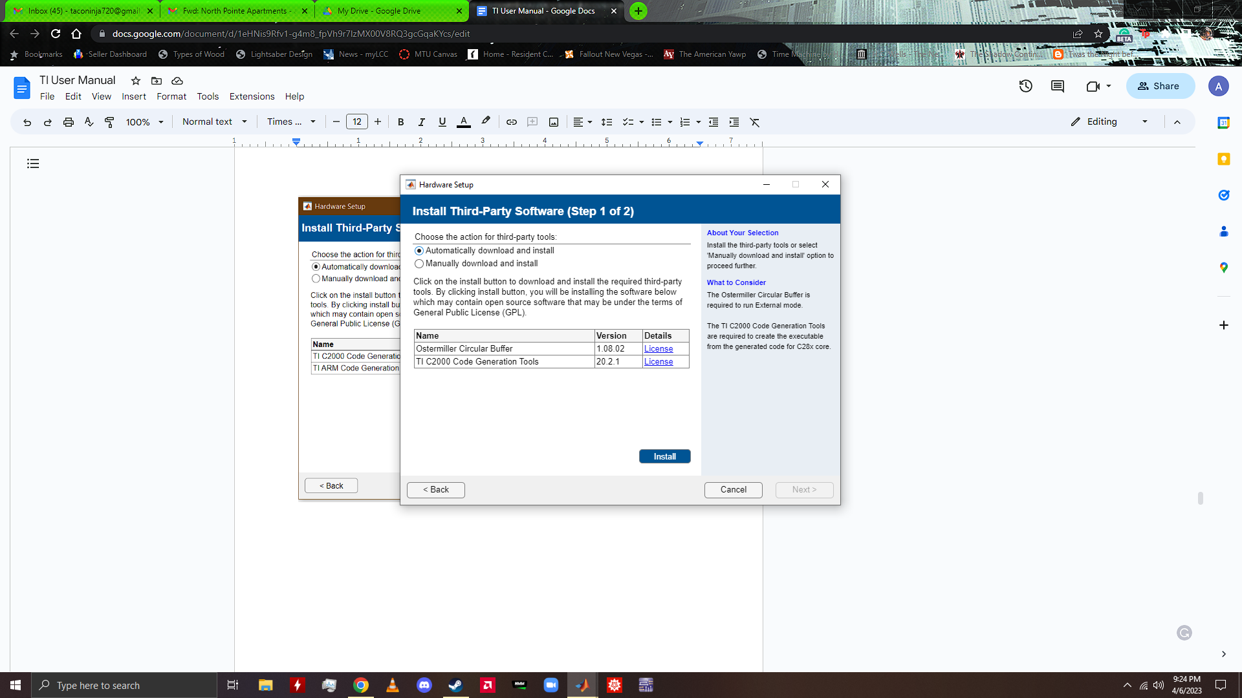

Figure 4: Third-Party Software Installation (PAGE 1)

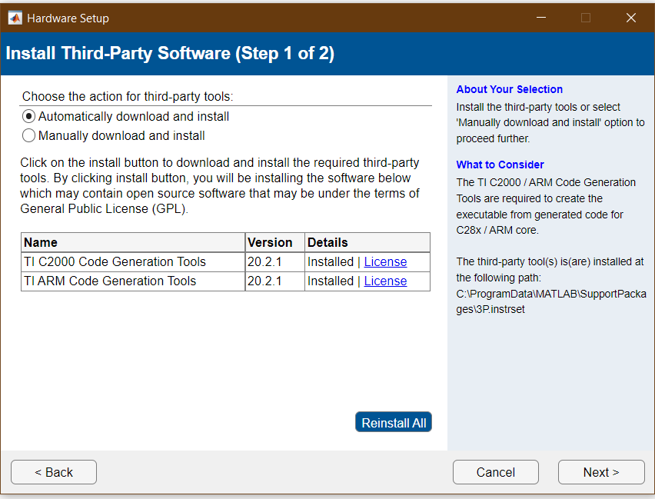

Figure 5: Confirmed Installation

- Following the directions on-screen, install the Third-Party Software highlighted in Figure 6
  - TI controlSUITE
    - Click the installation link seen in Figure 9. This will open a webpage
    - On the webpage, navigate to the downloads section
    - Download the option labeled “CONTROLSUITE - Web (EXE) installer”
      - A Texas Instruments Account is required
    - Open the executable file and follow the instructions in the installation wizard
  - TI Code Composer Studio
    - Click the installation link in Figure 9. This will open a webpage
    - Navigate to the download link for version 11.0.0
      - This revision is dated Oct 11, 2021
    - Click the download link labeled “Windows on-demand installer for CCS IDE”
    - Open the executable file and follow the instructions in the installation wizard
- Click Next after completing the installation process

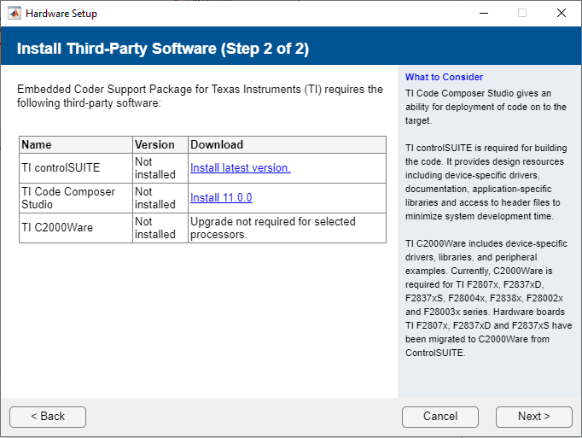

Figure 6: Third-Party Software Installation (PAGE 2)

- Using the textbox or Browse button, specify the folder where the TI Control Suite was installed
  - Figure “” shows the default installation path
- Click the validate button after selecting the proper installation path
  - If the installation path cannot be validated, return to the previous steps to verify proper installation
- After the installation path is validated, click Next

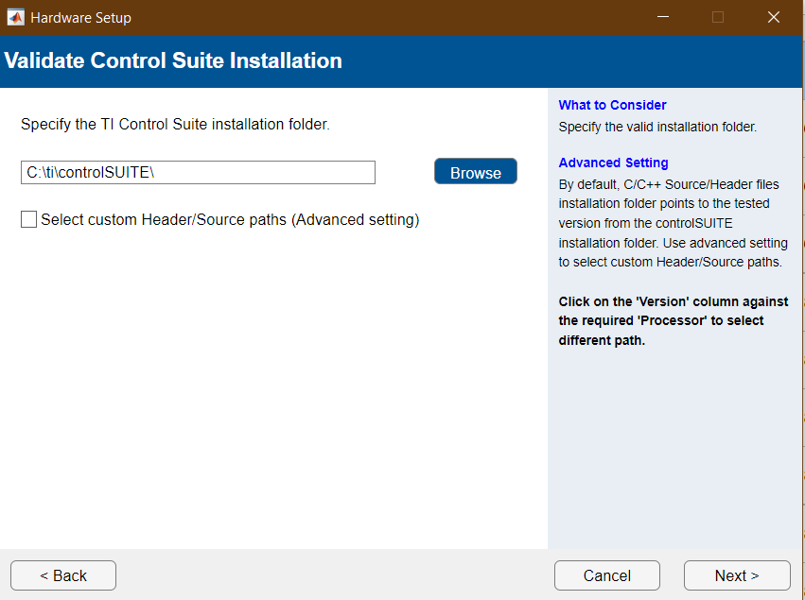

Figure 7: TI Control Suite Default Installation Path

- Like the previous step, use the textbox or Browse button, specify the folder where the TI Code Composer Studio was installed
  - Figure 11 shows the default installation path
- Click the validate button after selecting the the proper installation path
  - If the installation path cannot be validated, return to the previous steps to verify proper installation
- After the installation path is validated, click Next
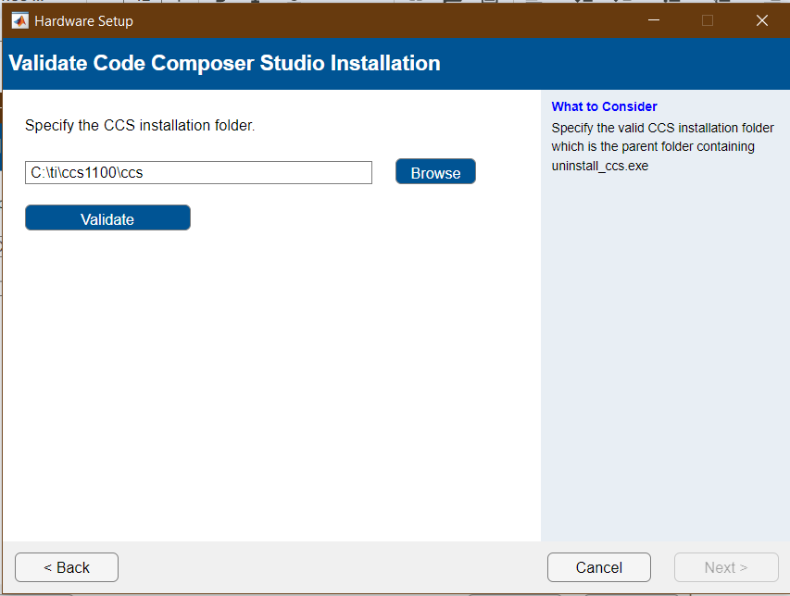

Figure 8: TI Code Composer Studio Default Installation Path

- Using the on-screen table, verify the installation of all Third-Party Software and Drivers
- Click Next
- A window will be displayed with a message confirming successful installation
- Click Finish
- The installation process is now complete
- Run openExample("c2b/DualMotorDynoUsingC2000ProcessorsExample") to open the original Mathworks dyno example model and environment
- For lab preparation, open the respective lab folder

